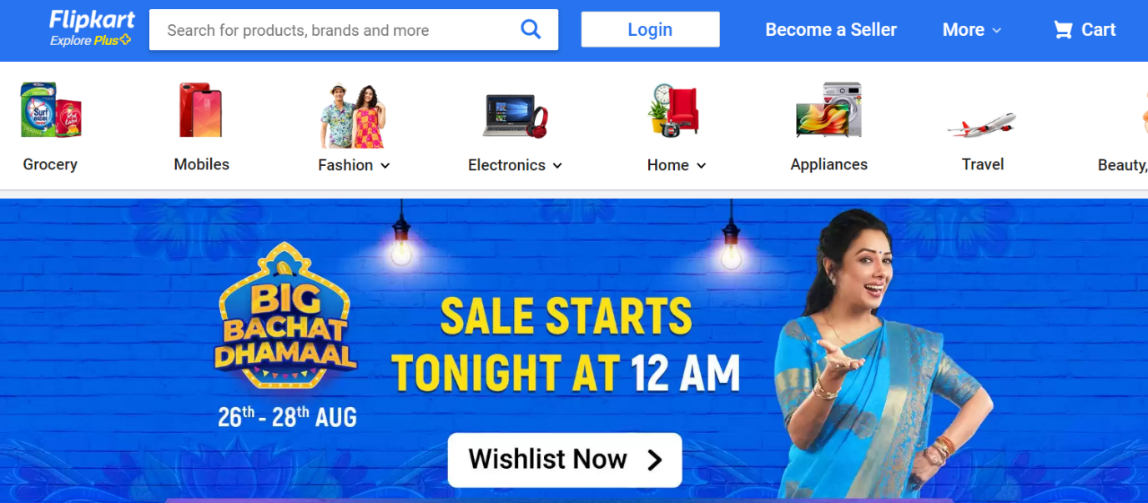

**Overview :**

Flipkart is an Online shopping site where we can buy all kinds of products by searching for all kinds of Brands, selecting a specific product, and paying online or offline.

**Main Pages in Flipkart consist of**

* Sign up page,
* Login Page
* Home page
* Product Page
* Payment Gateway

**Sign up Page:**

Sign page is to register the use by providing basic details like Name, Email ID, or Phone number

**Login Page**

The login page will ask us for the credentials to enter into the Home page.

Login can be an Email ID and Password or a One-time password with a Contact number

**Home Page:**

The home page consists of the

Menu bar

Search bar

Banners

Different products

Footer

**Product Selection page :**

The product Selection page is used to select the product we are looking for and we find detailed descriptions of the product before buying.

**Payment Gateway**

Payment gateway consists of the different methods to select the payment like Cash on delivery or Online payment(Credit card Debit card or Online Banking)

**Used Technologies**

Frontend : HTML, CSS, JavaScript, React

Backend: NodeJS

Database: MongoDB